

**Implementing AWS Web Application Firewall (WAF)**

Step 1: Create a launch template in EC2

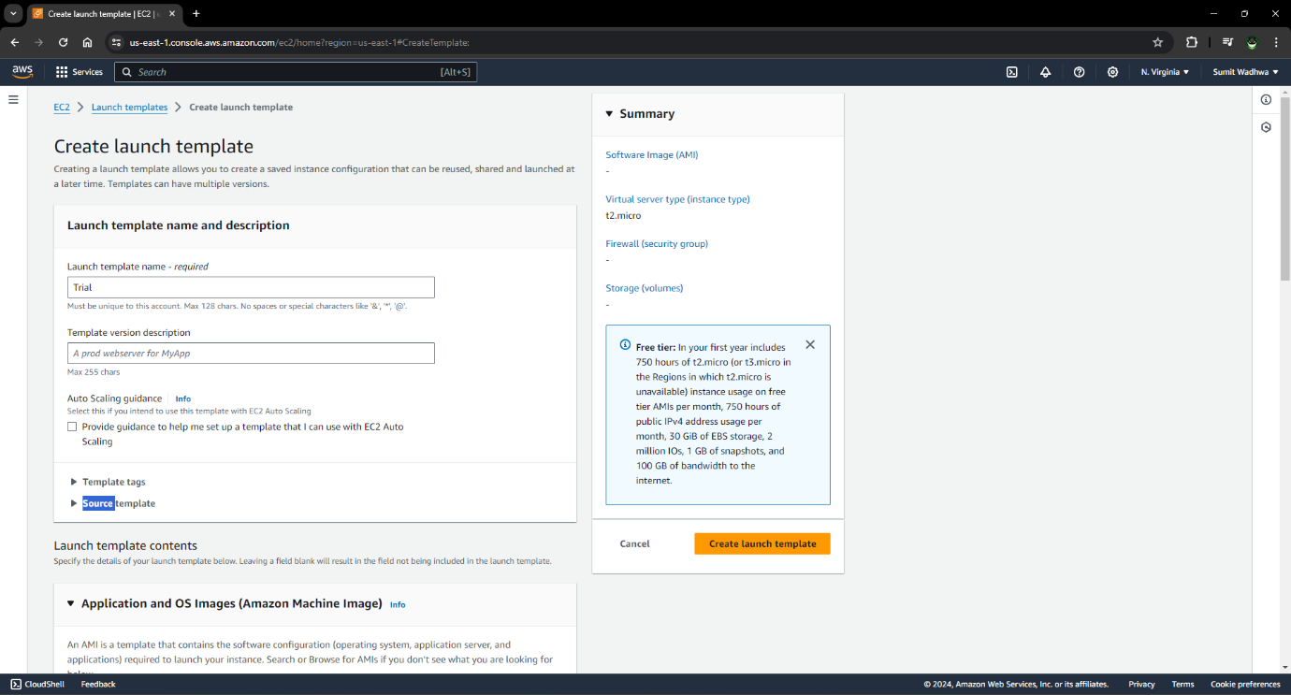

Step 2: Launch EC2 instance from launch template

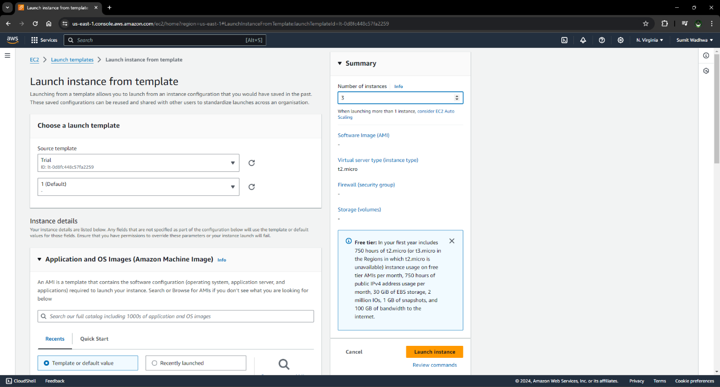

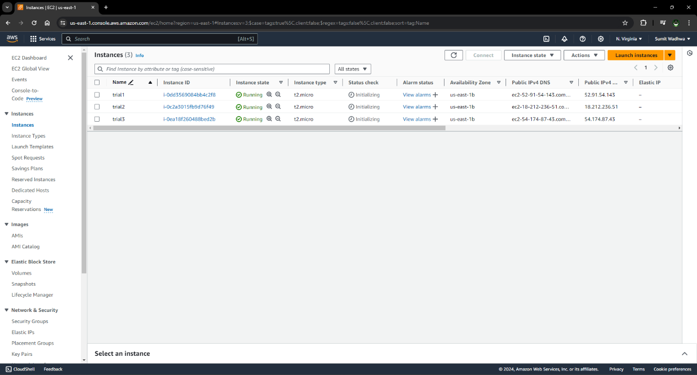

Step 3: Create a target group

* Enter target group details

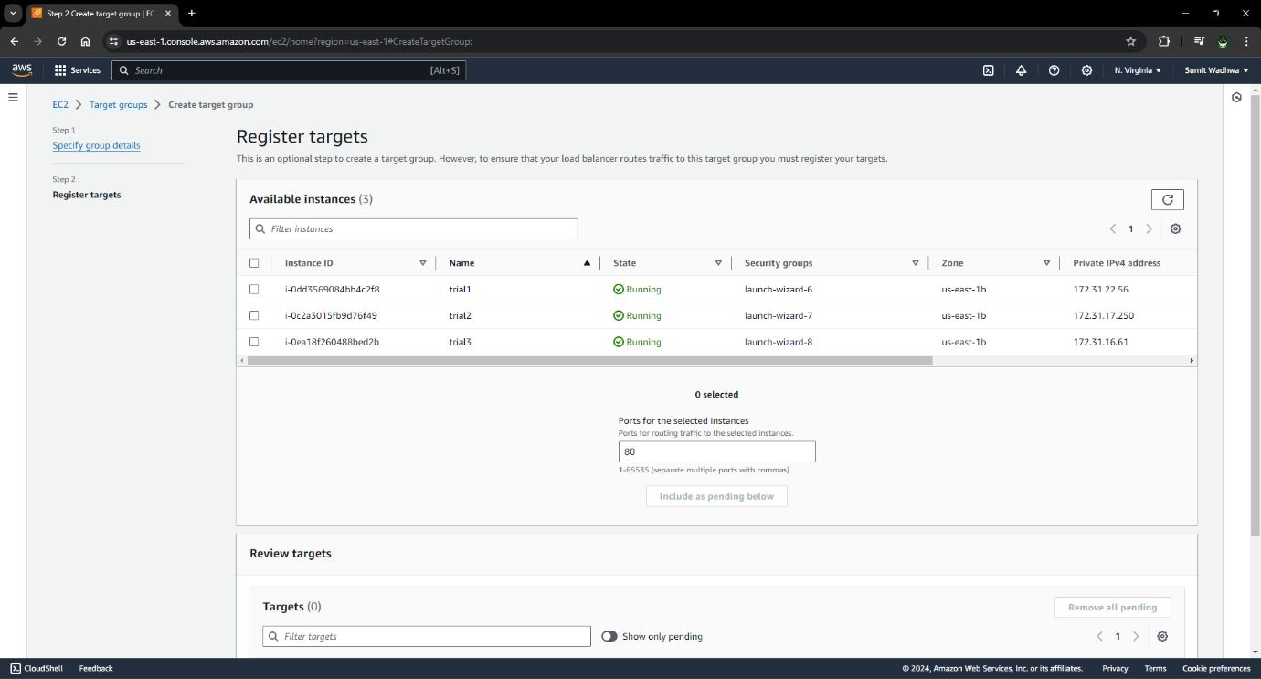

Step 4: Target group is created

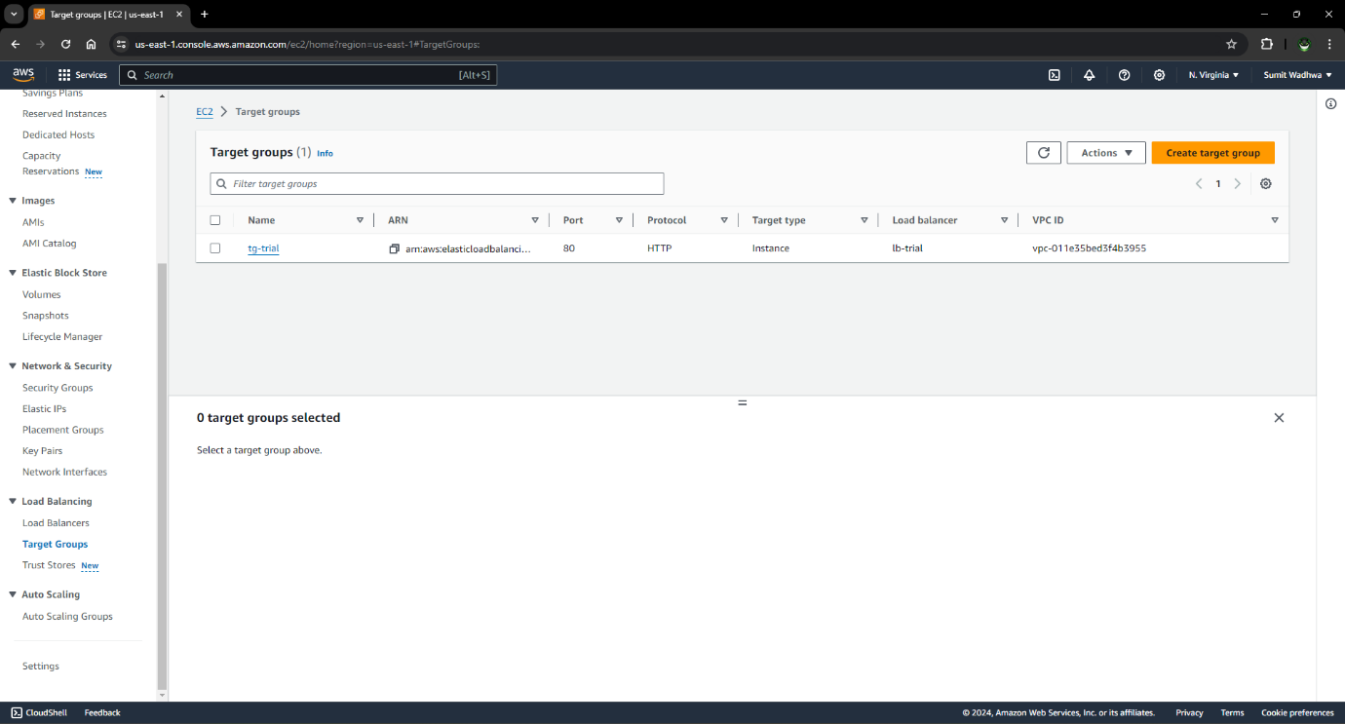

Step 5: Create an Application Load Balancer

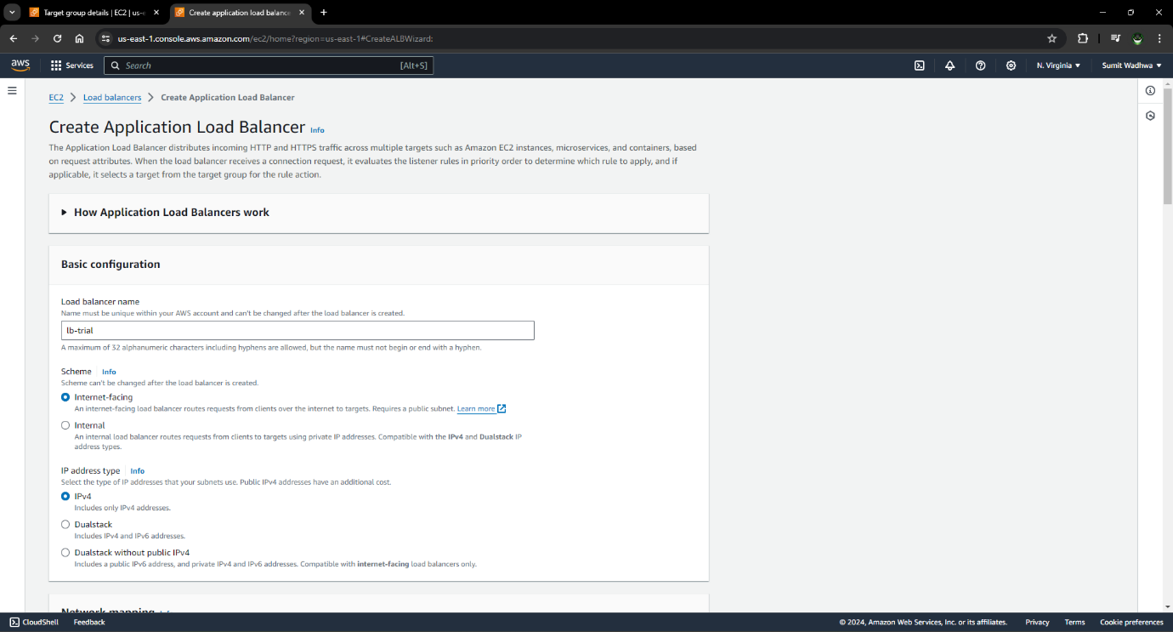

Step 6: Associate Application Load balance with target group

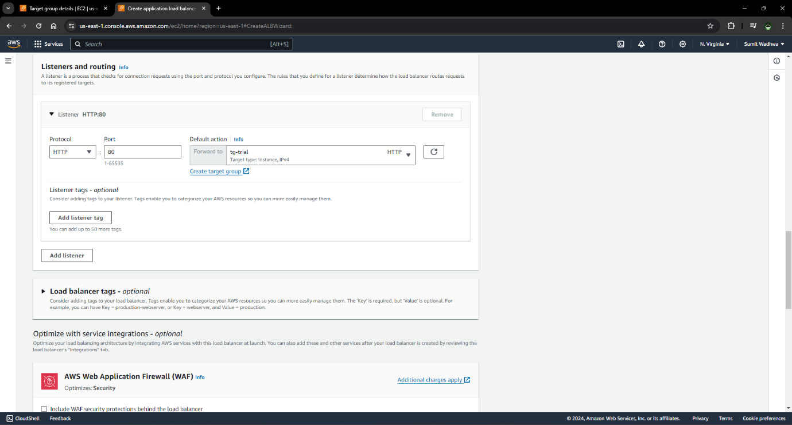

Step 7: Application load balancer is created

* Check it details

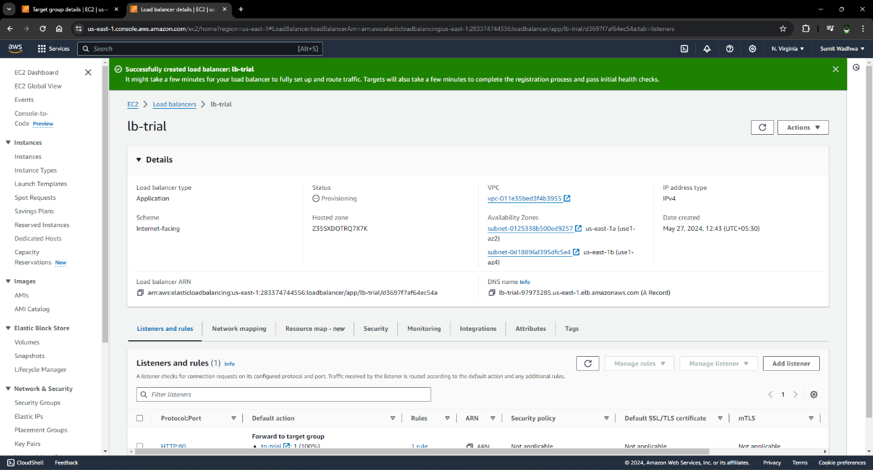

Step 8: Go to the search bar and open WAF & Shield

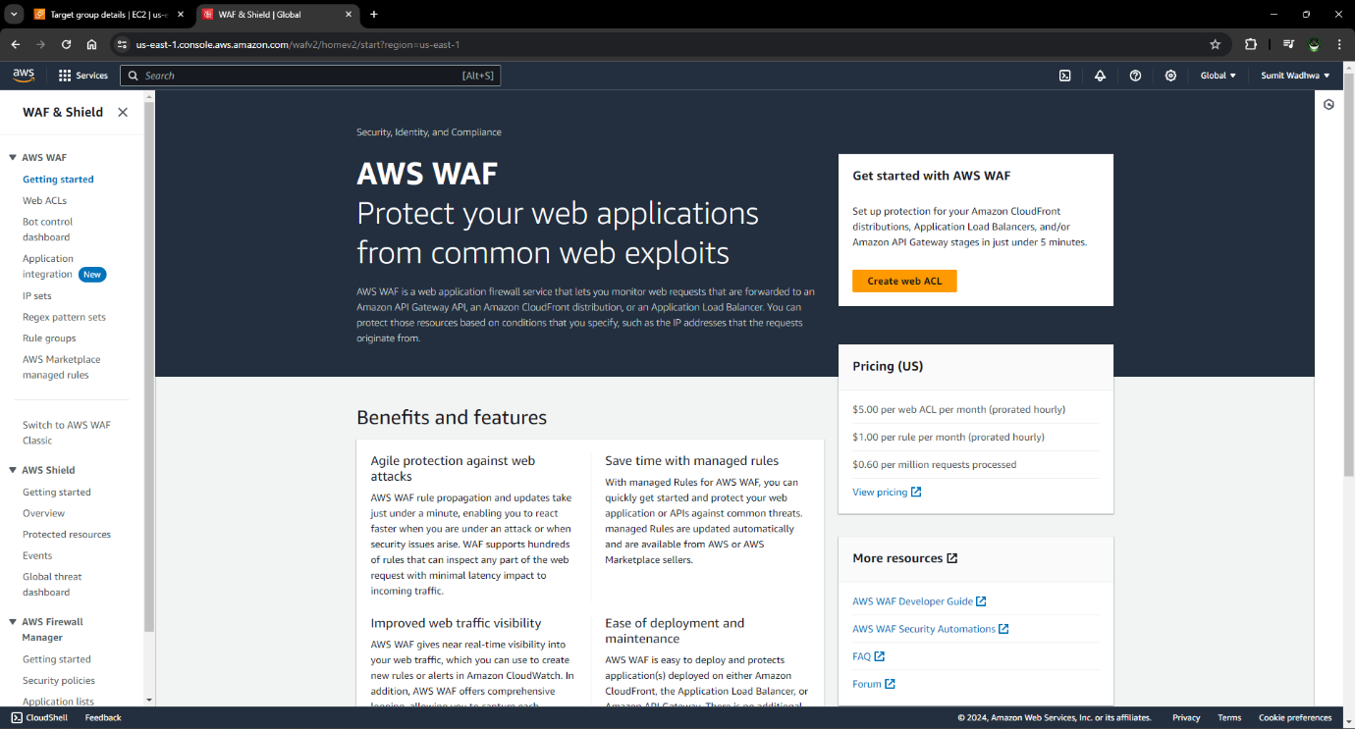

Step 9: Create IP sets

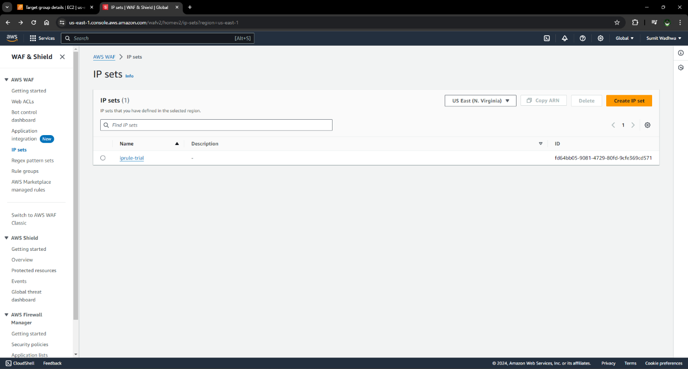

Step 9: Check IP set details and make sure your IP address is added

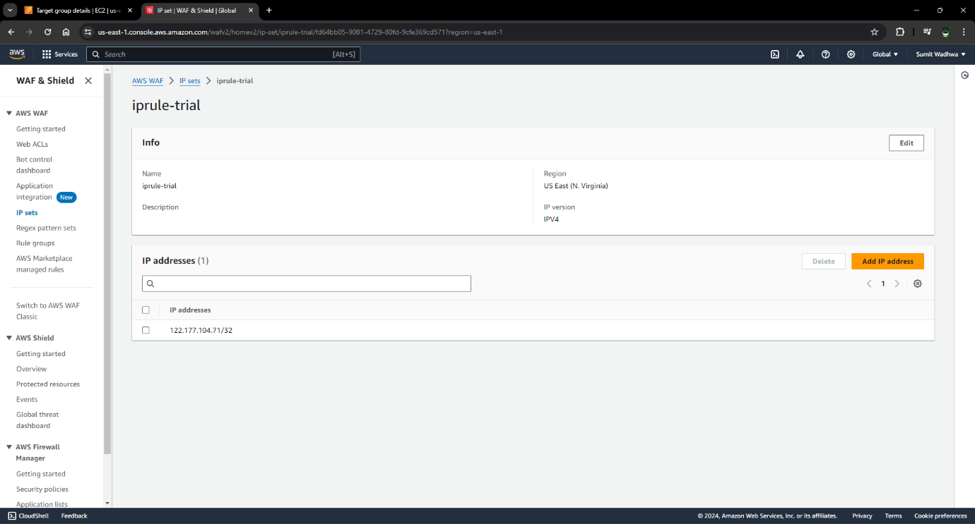

Step 10: Create Web ACL (Access Control List)

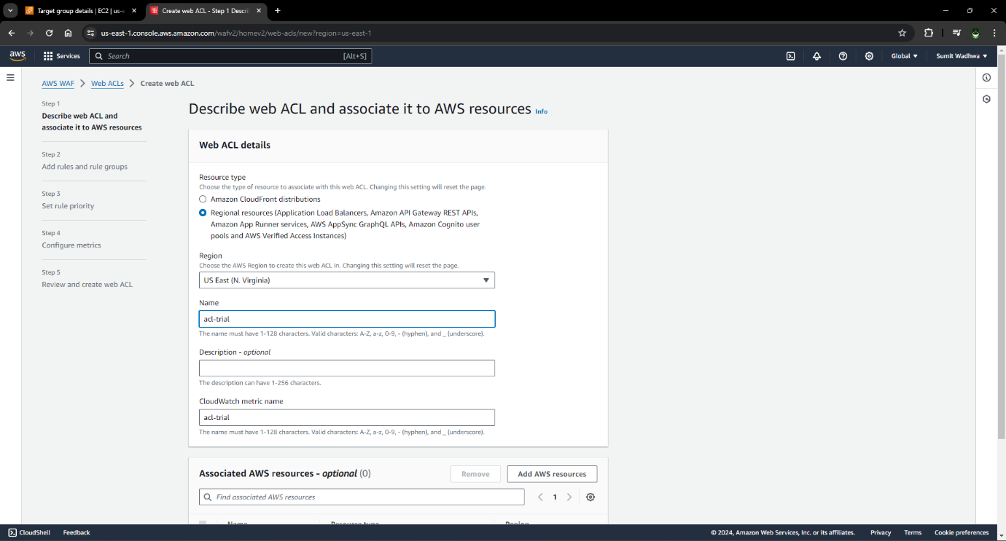

Step 11: Add AWS resources

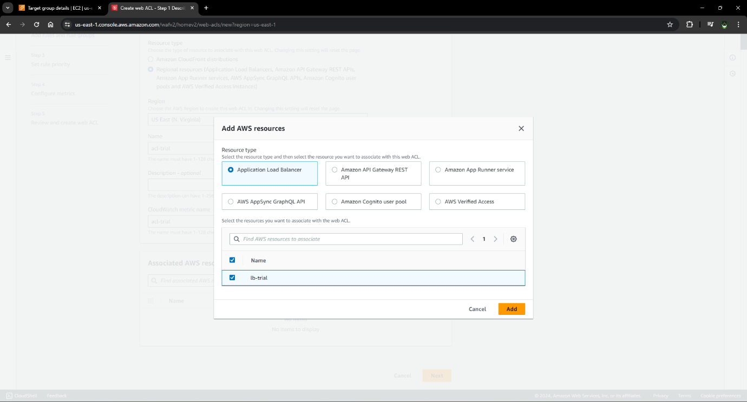

Step 12: Add rule and rule groups

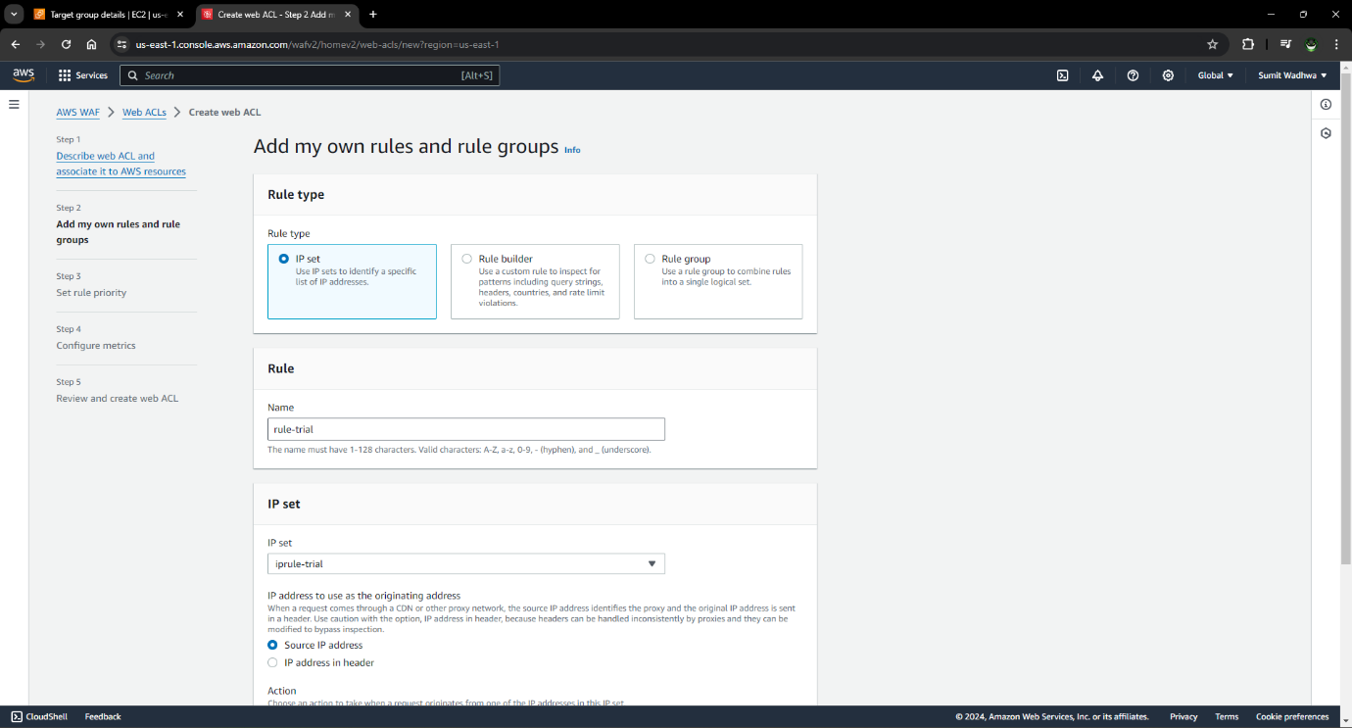

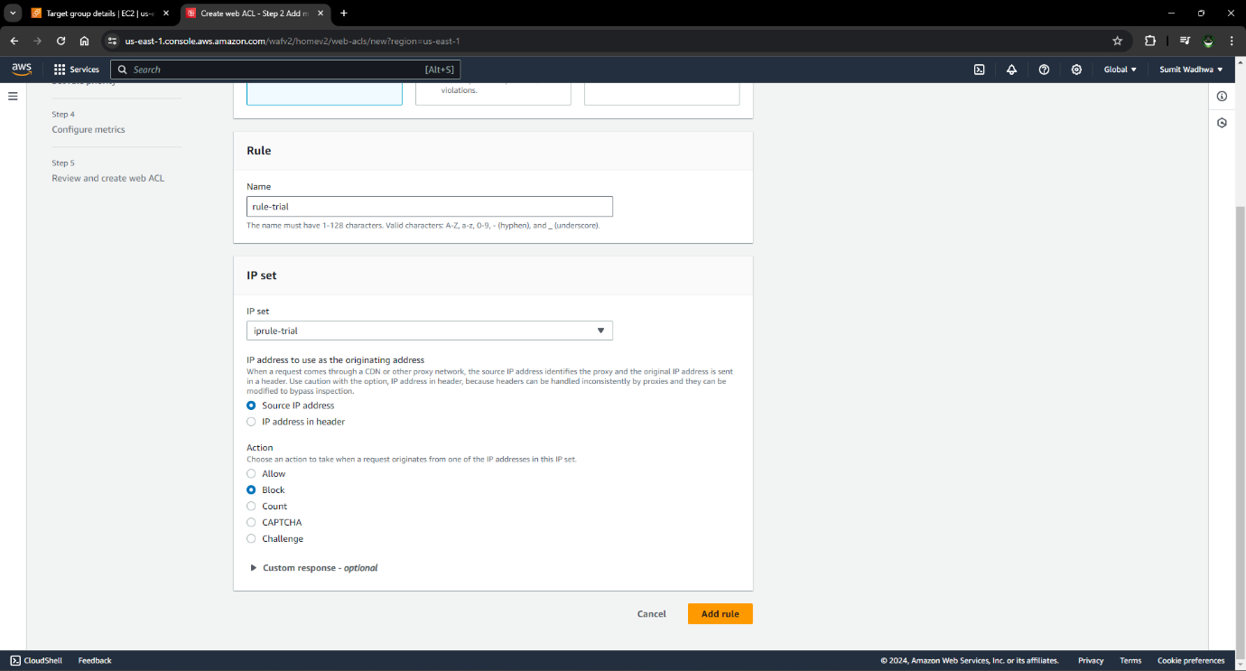

Step 13: Set rule priority

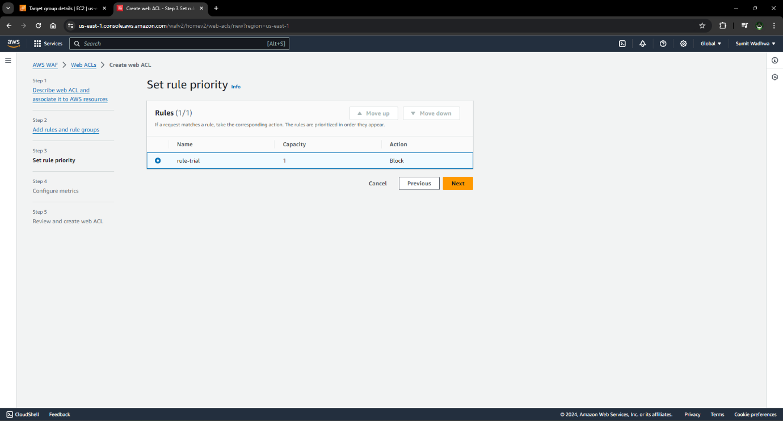

Step 14: Configure metrics

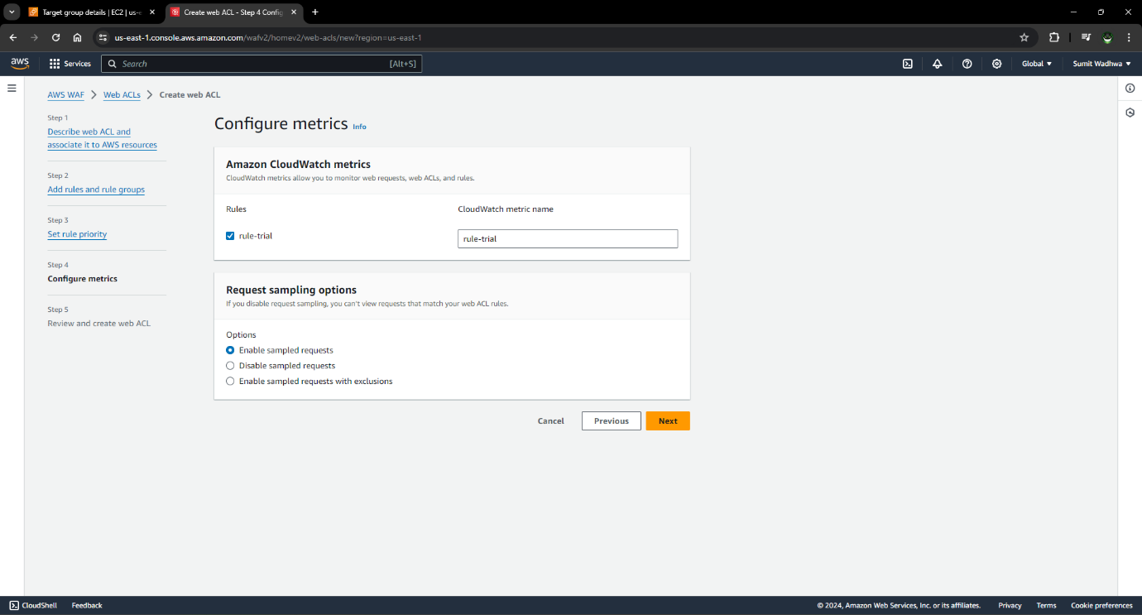

Step 15: Review and create web ACL

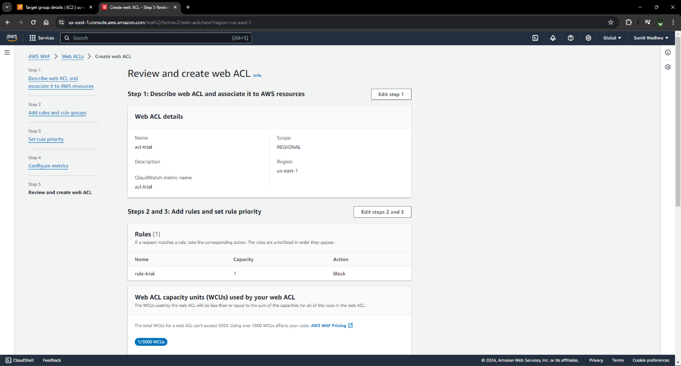

Step 16: Web ACL is created

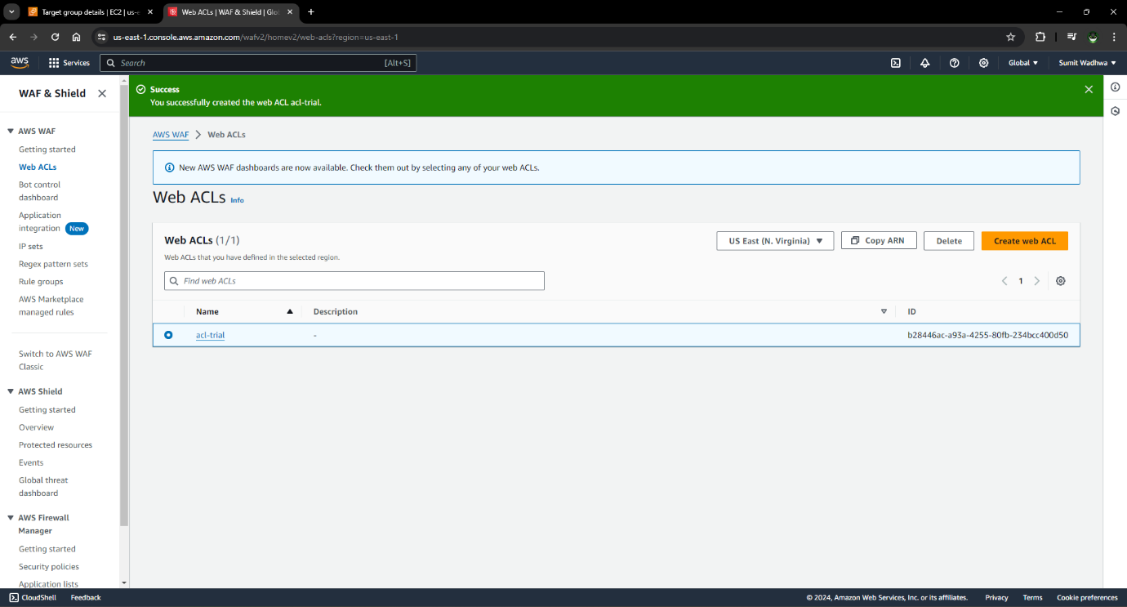

Step 17: Check the result

* You can check the result by trying to access load balancer from IP which is define in the IP set rules group
* There is 403 forbidden message because WAF blocked that IP
* The 403 error indicates that the website owner has set up rules that are blocking your IP address

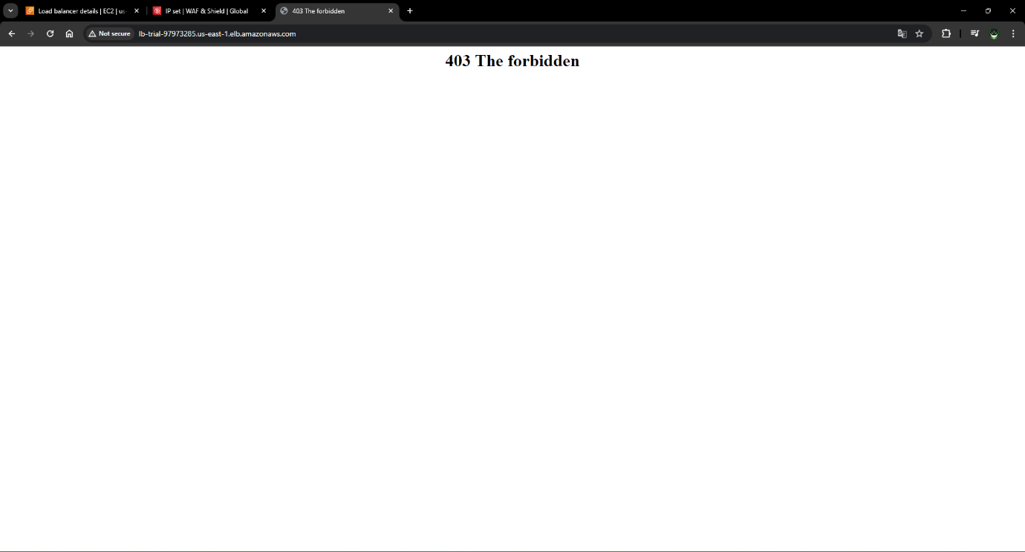

Step 18: From Web ACL traffic can be filtered and all the details can be checked like sample of bot detection, client device types, attack type, top 10 countries, blocked , allowed IPs

